Test Case: tc001_SPX_Dev5_Crear_Solicitud_Articulo_Almacen
Step 1 - Enter username and password and click to button Enter : Credentials Entered
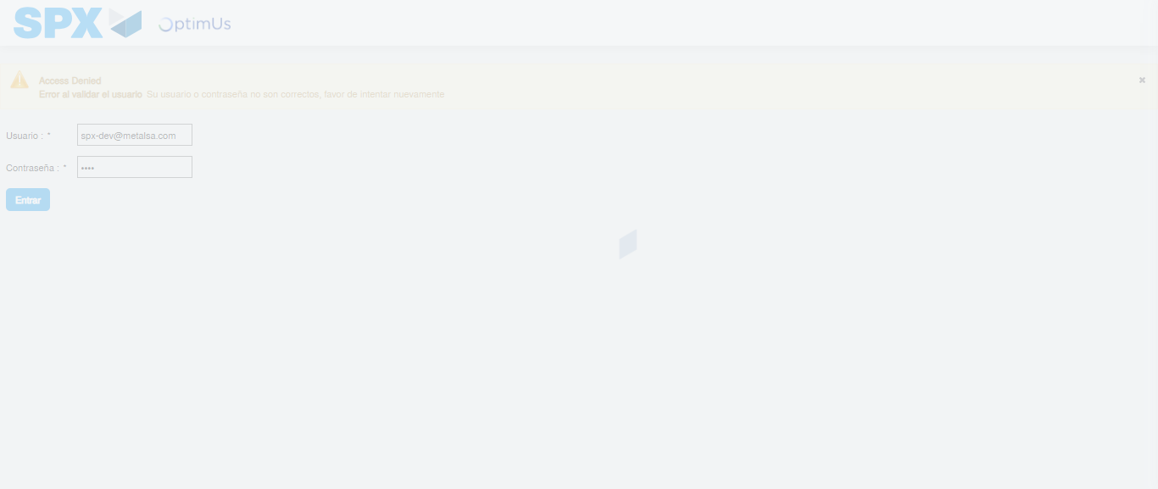Image file-name: QC_Testing-tc001_SPX_Dev5_Crear_Solicitud_Articulo_Almacen-1787841312284

Step 2 - Select to UEN and Access to Request for a New Inventory Item : UEN Correctly selected and Correct access
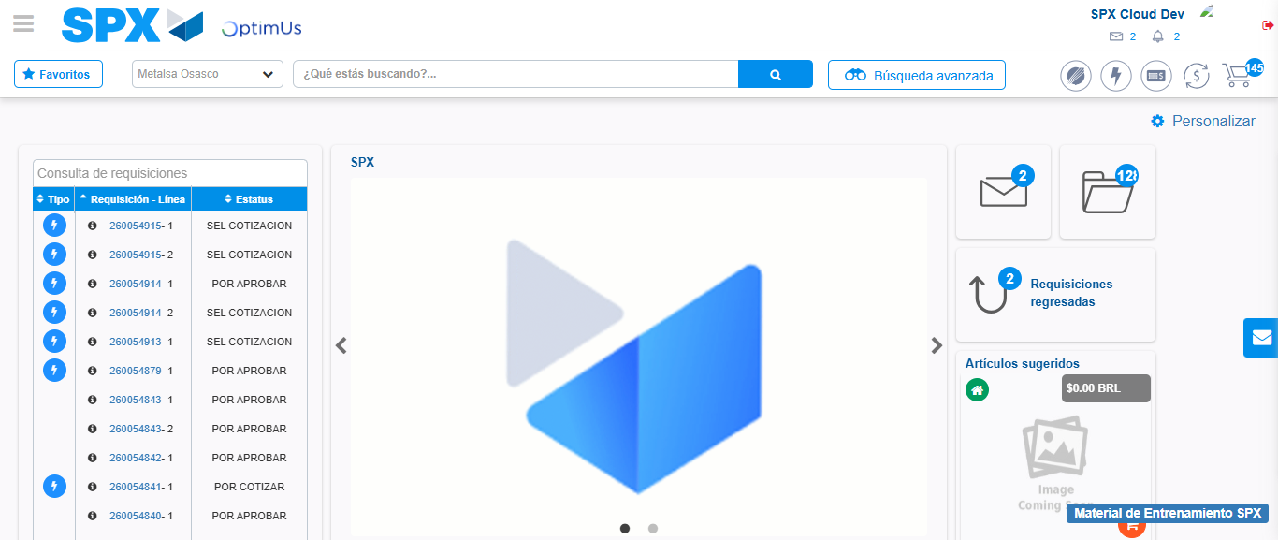Image file-name: QC_Testing-tc001_SPX_Dev5_Crear_Solicitud_Articulo_Almacen-1787841337768

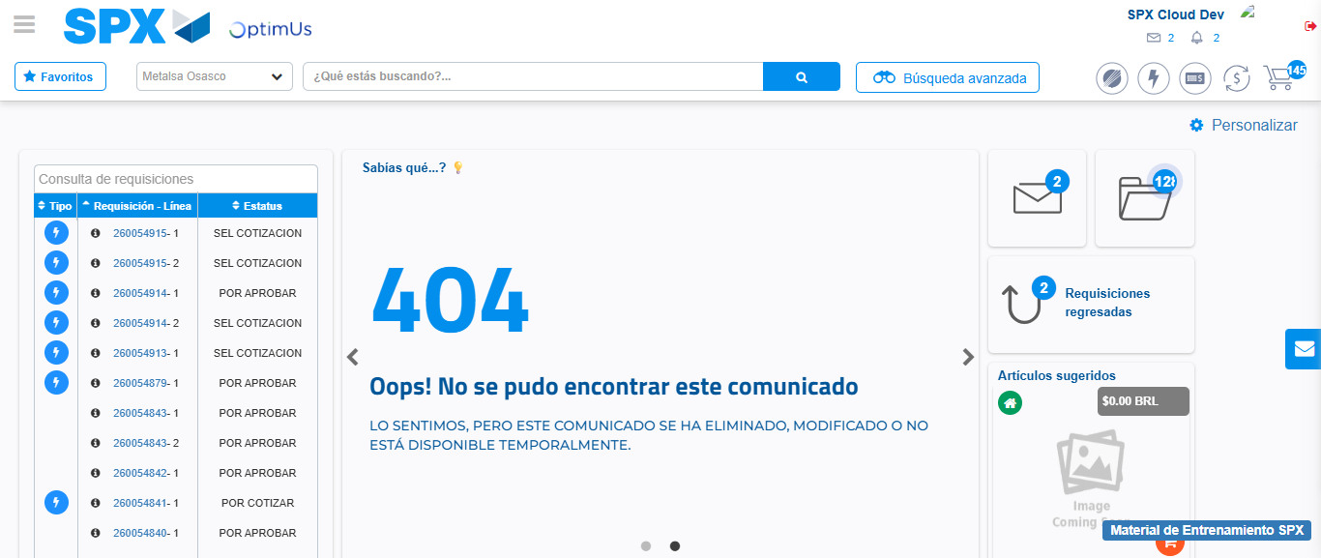Image file-name: QC_Testing-tc001_SPX_Dev5_Crear_Solicitud_Articulo_Almacen-1787841399091

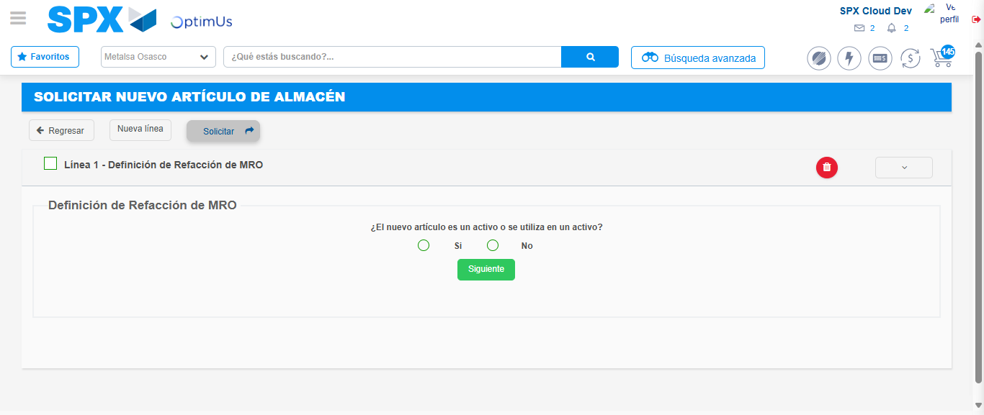Image file-name: QC_Testing-tc001_SPX_Dev5_Crear_Solicitud_Articulo_Almacen-1787841406510

Step 7 - Return to Main Page SPX : Return to Main Page SPX
Image file-name: QC_Testing-tc001_SPX_Dev5_Crear_Solicitud_Articulo_Almacen-1787841337768

Image file-name: QC_Testing-tc001_SPX_Dev5_Crear_Solicitud_Articulo_Almacen-1787841399091

Image file-name: QC_Testing-tc001_SPX_Dev5_Crear_Solicitud_Articulo_Almacen-1787841406510

Image file-name: QC_Testing-tc001_SPX_Dev5_Crear_Solicitud_Articulo_Almacen-1787841409039

Image file-name: QC_Testing-tc001_SPX_Dev5_Crear_Solicitud_Articulo_Almacen-1787841409201

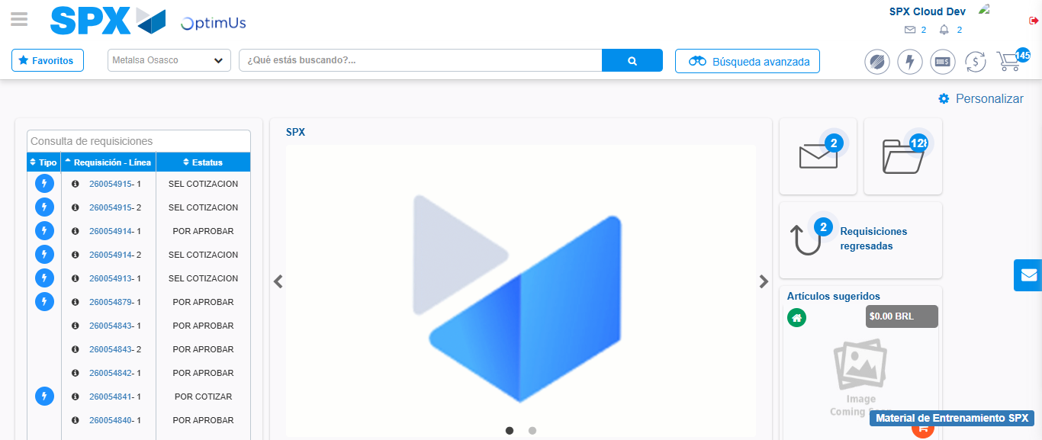Image file-name: QC_Testing-tc001_SPX_Dev5_Crear_Solicitud_Articulo_Almacen-1787841430479

Step 8 - Log Out : Log Out SPX
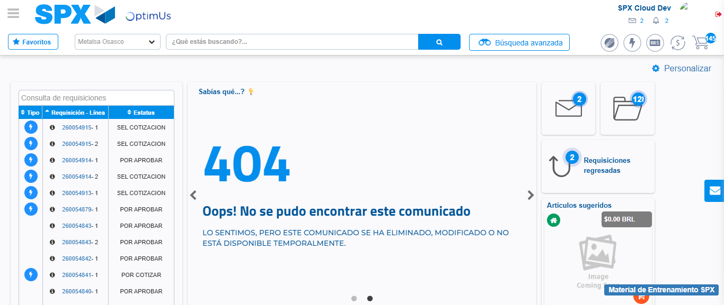Image file-name: QC_Testing-tc001_SPX_Dev5_Crear_Solicitud_Articulo_Almacen-1787841451294

